**1. Select Your Operating System (OS)**

Before starting, ensure you meet the following requirements:

A compatible PC with a minimum of 1 GHz processor, 4 GB RAM, 64 GB storage, and TPM version 2.0.

A Windows 11 installation media (USB/DVD) or an ISO file.

A USB flash disk with a capacity of 8 GB.

Step 1: Preparing Installation Media

Download the Windows 11 ISO:

Visit the official Microsoft Windows 11 download page at https://www.microsoft.com/software-download/windows11

- Download the ISO file or use the Media Creation Tool to create a bootable USB drive.

- Create a Bootable USB Drive (if using ISO):

- Use tools like Rufus or PowerISO to create a bootable USB drive.

- Select the downloaded ISO file and follow the on-screen instructions.

The Create bootable USB drive for Windows 11 image is displayed below using the Rufus app that can be downloaded from https://rufus.ie/en/.

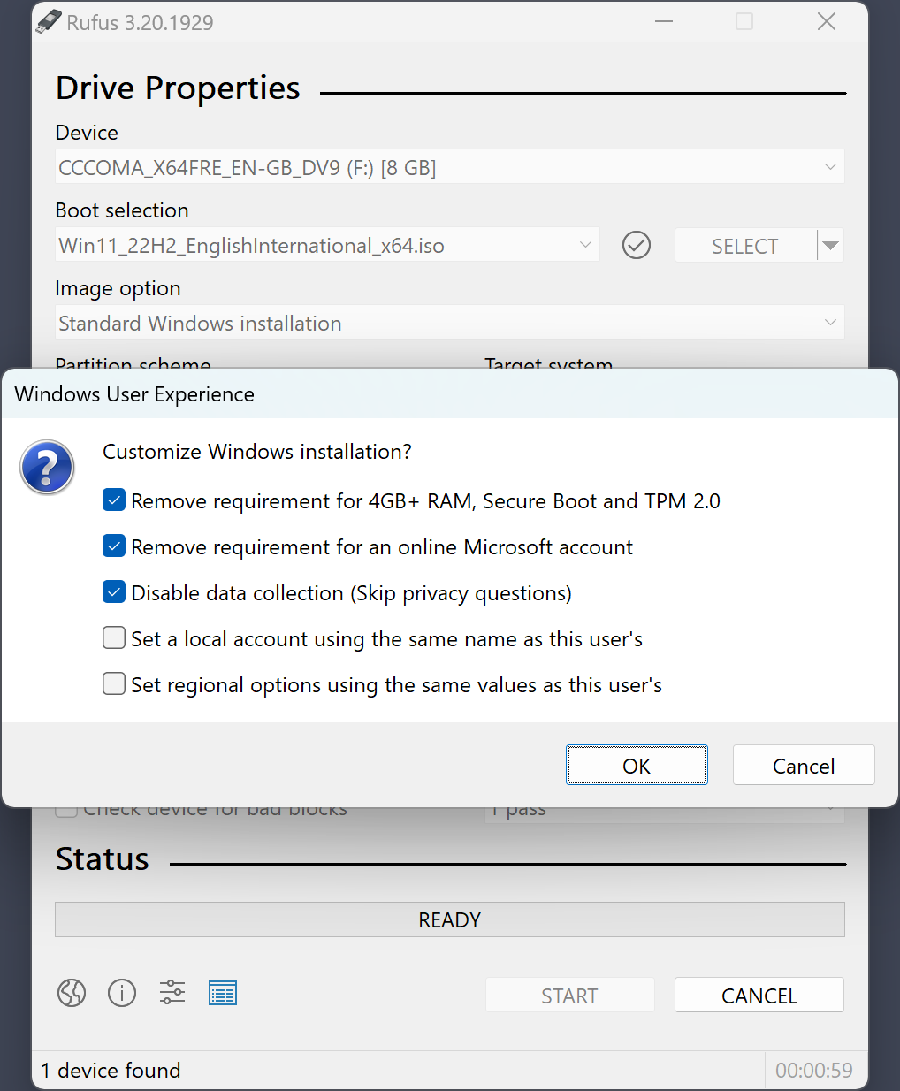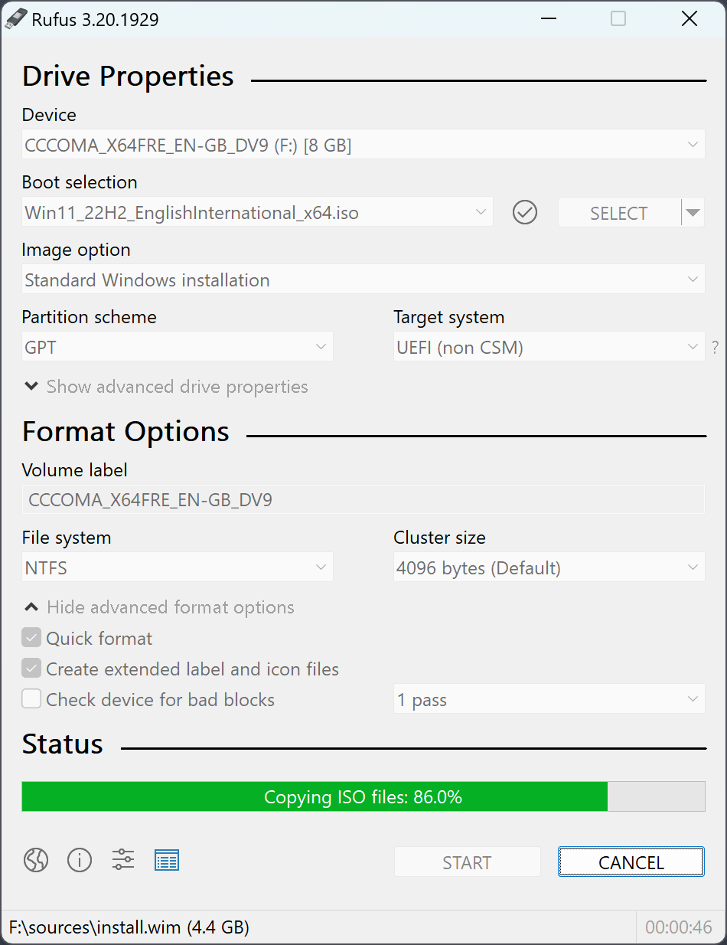

Step 2: Installing Windows 11

Insert the Installation Media:

- Insert the USB drive into your PC.

- Restart your PC and press the boot menu key (F12, F2, DEL, etc.) during startup to boot from USB.

- Start Installation:

- Select your language, time, and keyboard preferences.

- Click Next and then Install Now.

Image below shows the steps on how to select the Language, keyboard layout and time or currency format

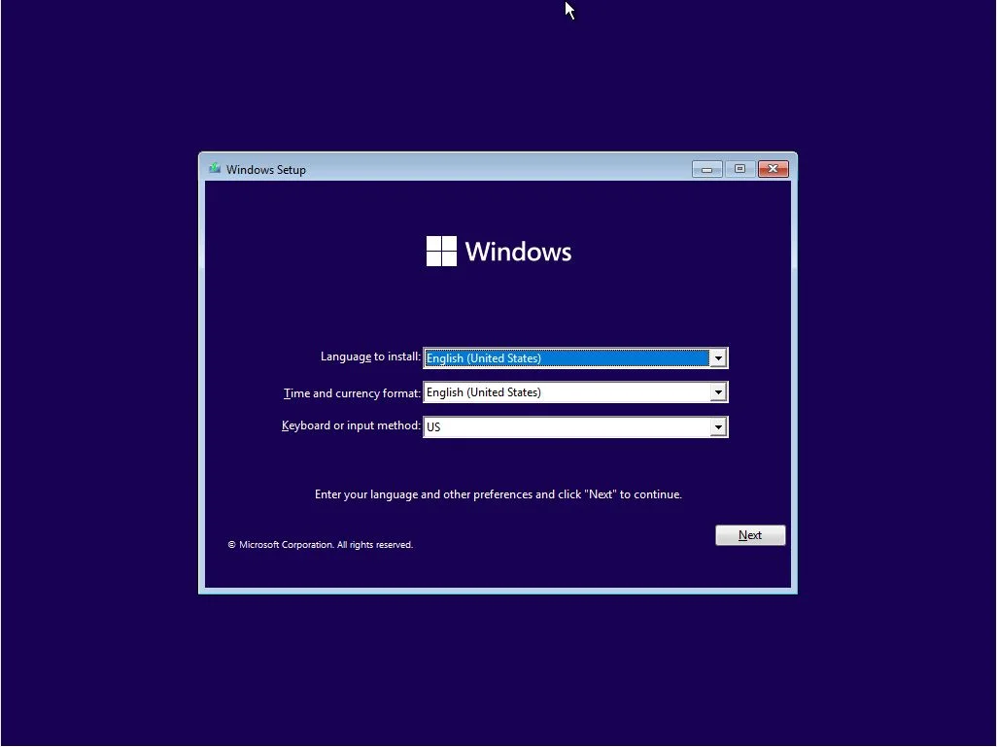

Enter Product Key:

- Enter your Windows 11 product key or choose "I don't have a product key" to proceed without one.

Accept License Terms:

- Read and accept the license terms by checking the box and clicking Next.

Select Installation Type:

- Choose Custom: Install Windows only (advanced).

Select Partition:

- Select the partition where you want to install Windows 11.

- If necessary, create or format partitions.

Begin Installation:

- Click Next to start the installation. Your PC will restart several times during this process.

Windows 11 will begin installing as shown below after the user has agreed to the terms and conditions, read the license agreements, selected partitions or made a partition on a PC hard drive.

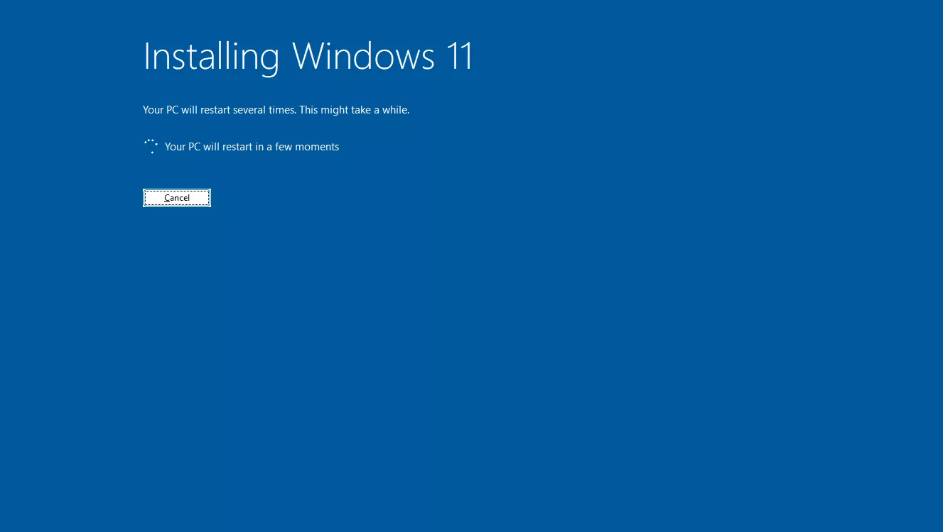

Step 3: Setting Up Windows 11.

Once the installation is complete windows will require the user to setup it up as shown below

Initial Setup:

- After installation, you'll see the "Out of Box Experience" (OOBE) screen.

- Select your region and click Yes.

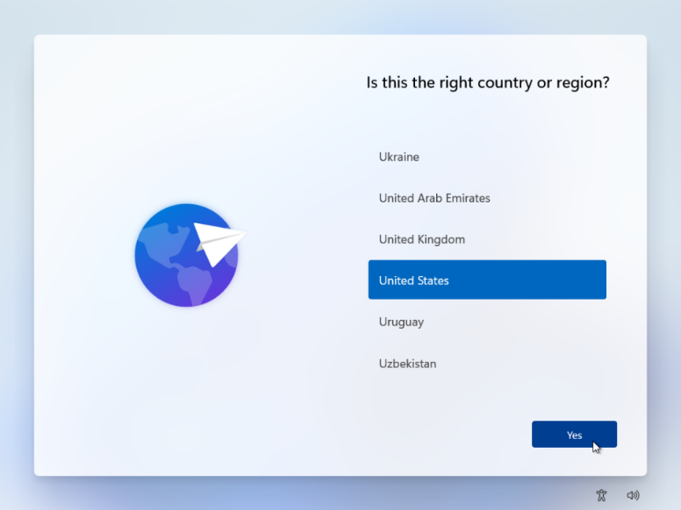

Keyboard Layout:

- Choose your keyboard layout and add a second layout if needed.

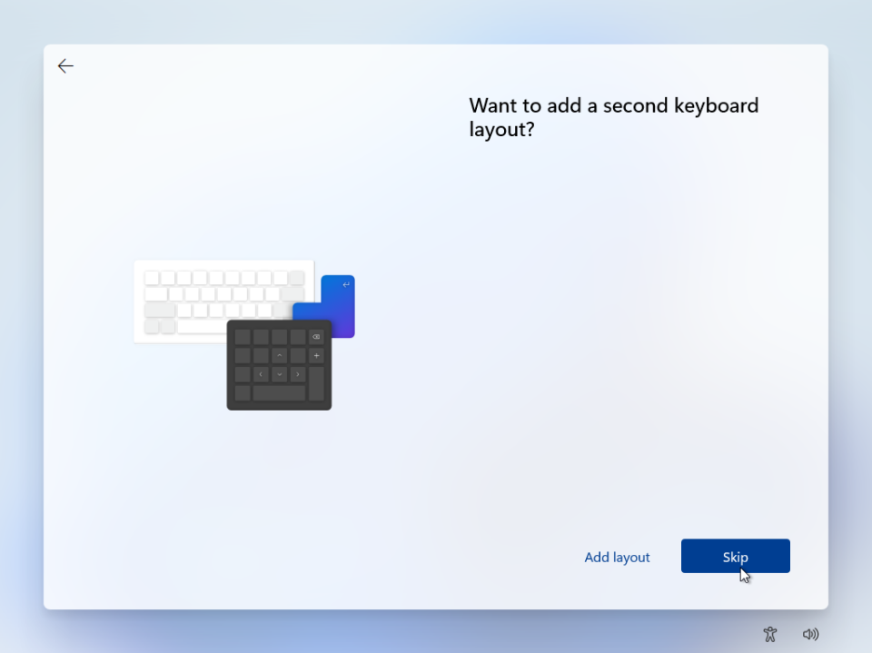

Connect to a Network:

- Connect to a Wi-Fi network or click Skip for now if using an Ethernet connection.

Sign In:

- Sign in with a Microsoft account or create a new one.

- You can also choose an offline account.

- You can then select the account type

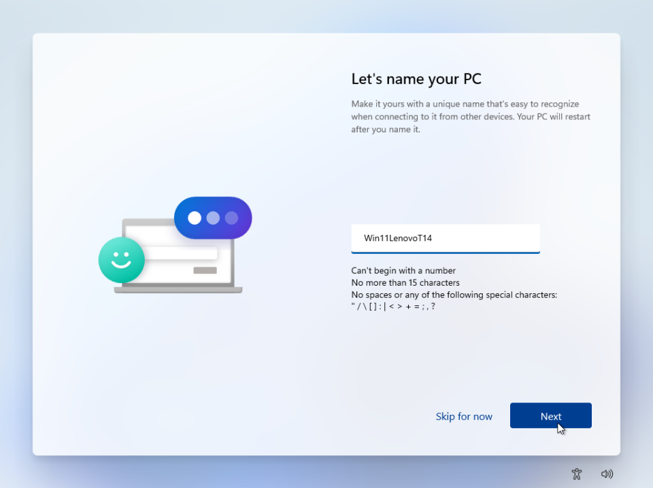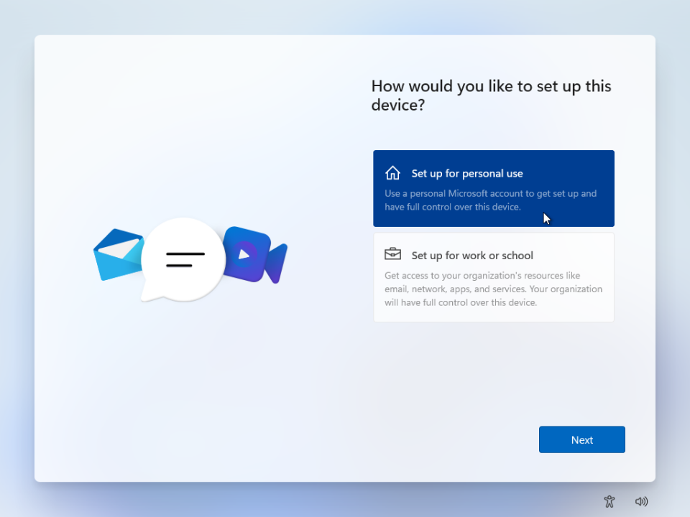

Create a PIN:

- Set up a PIN for quick and secure sign-in.

Privacy Settings:

- Adjust privacy settings according to your preferences.

Get Updates:

- Windows will check for and install updates.

Step 4: Finalizing Setup

Desktop Setup:

- After completing the setup, you'll see the Windows 11 desktop.

- Customize your settings, install drivers, and set up applications as needed.

**2. Install a Text Editor or Integrated Development Environment (IDE)**

Installation

- Download the Visual Studio Code installer for Windows from https://code.visualstudio.com/Download

- Once it is downloaded, run the installer (VSCodeUserSetup-{version}.exe). This will only take a minute.

- By default, VS Code is installed under C:\Users\{Username}\AppData\Local\Programs\Microsoft VS Code.

- Alternatively, you can also download a Zip archive, extract it and run Code from there.

The Setup will add Visual Studio Code to your %PATH%, so from the console you can type 'code .' to open VS Code on that folder. You will need to restart your console after the installation for the change to the %PATH% environmental variable to take effect.

User setup versus system setup

VS Code provides both Windows user and system level setups.

The user setup does not require Administrator privileges to run as the location will be under your user Local AppData (LOCALAPPDATA) folder. Since it requires no elevation, the user setup is able to provide a smoother background update experience. This is the preferred way to install VS Code on Windows.

Note: When running VS Code as Administrator in a user setup installation, updates will be disabled.

The system setup requires elevation to Administrator privileges to run and will place the installation under the system's Program Files. The in-product update flow will also require elevation, making it less streamlined than the user setup. On the other hand, installing VS Code using the system setup means that it will be available to all users in the system.

**3. Set Up Version Control System**

Installation of Git on Windows 11

Navigate to the latest Git for Windows installer and download the latest version at <https://www.git-scm.com/download/win>

Once the installer has started, follow the instructions as provided in the Git Setup wizard screen until the installation is complete.

- Open the windows command prompt (or Git Bash if you selected not to use the standard Git Windows Command Prompt during the Git installation).

- Type git version to verify Git was installed.

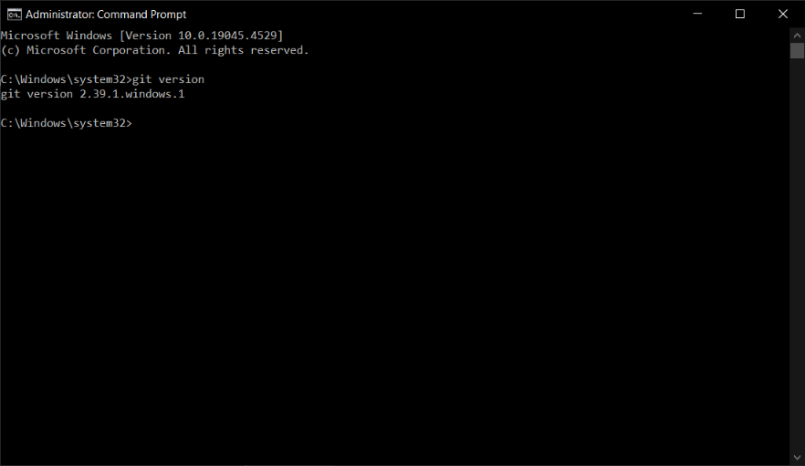

As an alternative, you can click the Windows 11 Start button, search for recently installed apps, or type "Gitbash" to launch the Gitbash CLI, provided that it has been installed correctly. Once the Gitbash application is located, you can use the command "git - -version" to see what version is installed and execute it as administrator.

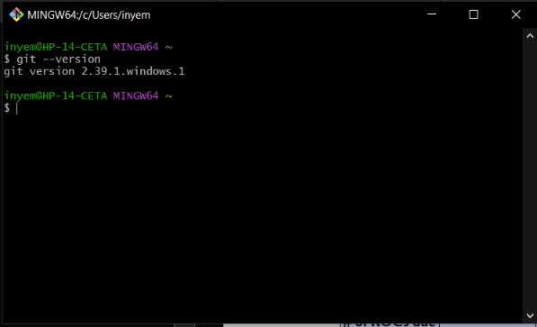

**Gitbash Configurations**

After installing Git on your PC, you should set up your Git environment in a few different ways. These tasks should only need to be completed once on a particular computer; they will persist in between upgrades. Additionally, you can modify them whenever you want simply repeating the commands.

The git config tool, included with Git, allows you to get and modify configuration variables that govern every element of Git is appearance and functionality. Three locations can be used to store these variables:

1. **Configuring User Identity**

Setting your email address and user name should be your first step in installing Git. This is significant because, once you begin creating commits, this information is irreversibly baked in and used by every Git commit:

Below are the commands for user identification.

$git config --global user.name "John Doe"

$git config --global user.email [johndere@proton.me](mailto:johndere@proton.me)

1. **Configuring Your Editor**

Now that your identification is established, you can specify the default text editor that Git will use to enter messages. Git utilises the default editor on your system if it is not set.

You can do the following to use an alternative text editor, like Emacs:

$ git config --global core.editor emacs

1. **Your default branch name**

By default Git will create a branch called master when you create a new repository with git init. From Git version 2.28 onwards, you can set a different name for the initial branch.

To set main as the default branch name do:

$ git config --global init.defaultBranch main

1. **Checking Your Settings**

If you want to check your configuration settings, you can use the git config --list command to list all the settings Git can find at that point:

$ git config --list

user.name=John Doe

user.email=johndere@proton.me

color.status=auto

color.branch=auto

color.interactive=auto

color.diff=auto

**4. Installing Programming Language and Runtime**

Installing the complete installer of Python is the best option for experienced developers that require a fully functional Python programming environment. Compared to installing via the Microsoft Store, it provides greater control and customisation over the installation process.

Installing from the whole installer only takes two steps.

Step 1: Download the Official Installer

Follow these steps to download the full installer:

Using Google Chrome open a new window and navigate to the <https://www.python.org/ftp/python/3.12.4/python-3.12.4-amd64.exe> to download the python language.

Step 2: Run the Installer

Run the installer by double-clicking the downloaded file. You should see the following window:

Follow these steps to complete the installation:

* Press Continue a few times until you’re asked to agree to the software license agreement. Then click Agree.
* You’ll be shown a window that tells you the install destination and how much space it will take. You most likely don’t want to change the default location, so go ahead and click Install to start the installation.
* When the installer is finished copying files, double-click the Install Certificates command in the finder window to make sure your SSL root certificates are updated.

5. Configure a Database (MySQL)

Detailed Installation Instructions

1. Get the MySQL Installer.

* Visit the MySQL Downloads section at <https://dev.mysql.com/downloads/installer/>
* Select the suitable edition and obtain the MSI installer.

2. Launch the Installer

* Run the MSI file that was downloaded.
* Select the type of setup:
* Developer Default: Contains documentation, MySQL Workbench, MySQL Router, MySQL Shell, and MySQL Server.
* Server Only: Just the MySQL Server is installed.
* Installs libraries and programmes for MySQL clients alone.
* Complete: Installs every MySQL product on the market.
* Custom: Gives you the option to select specific parts.

3. Licence Agreement for the Installation Process: To continue, please accept the licence agreement.

* Verification Requirements: The installation looks for necessary applications, such as Redistributable Visual C++.
* Select the Installation Path. Choose the installation directory (C:\Program Files\MySQL\MySQL Server 8.4 is the default).

4. Set up the MySQL server.

Type of server configuration:

* Development Machine: Little use of resources.
* Server Machine: Use of resources is moderate.
* Dedicated Machine: Excessive use of resources.

Interaction:

* Port: 3306 is the default.
* Network: If necessary, set up firewall rules.

Verification:

* Use either the Legacy Authentication Method or Strong Password Encryption (which is advised).
* Strong root passwords should be set.
* Create Users: Feel free to make more than one user account.

5. Set Up Windows Services

* The default Windows service name is MySQL80.
* Startup: Select the Windows service option to launch the MySQL Server.
* Standard System Account: Suggested for installations that are common.

6. Make Use of Configuration

* Examine the configuration parameters and implement the changes.
* Execute: To apply the configuration and launch the MySQL Server, click Execute.

7. Setup Complete

Setup for the Product:

* If the MySQL Router is installed, configure it to complete the configuration.

Finish:

* To finish the installation, click Finish.

Post-Installation

MySQL Workbench:

* Connect to the MySQL Server and carry out administrative duties using MySQL Workbench.

Command Line:

* To execute SQL commands directly, use the mysql command-line client.

In general, configuring a working environment using Windows 11, VSCode, Git Bash, MySQL, and Python can be difficult. However, these difficulties can be addressed and a fruitful development environment can be created with careful preparation, close attention to detail, and the appropriate techniques.

References

<https://pureinfotech.com/rufus-create-bootable-windows-11-usb/>

<https://realpython.com/installing-python/>

<https://dev.mysql.com/doc/refman/8.4/en/windows-installation.html>

<https://git-scm.com/book/en/v2/Getting-Started-First-Time-Git-Setup>